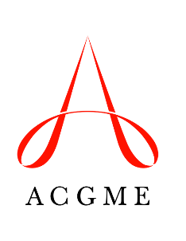
ONMM1 Application
Review Committee for Osteopathic Neuromusculoskeletal Medicine

Beginning July 1, 2019, the Review Committee for Osteopathic Neuromusculoskeletal Medicine (ONMM) will accept requests from accredited programs that seek to educate residents in the ONMM1 year. This form must be completed as part of the request. Review the Process to Request Approval for the ONMM1 Year document for more information.

Program Name:

Program Number:

Current Complement:

List the physician faculty members who will supervise the residents in the ONMM1 year.

Name | Credentials (DO/MD) | Board Certification  (Certifying body, Specialty/Subspecialty, Status)
Add rows as needed.

List additional participating sites that will be used by the program as a result of adding the ONMM1 year. If no additional sites are added, indicate N/A in the table.

Participating Site Name | Address | Rotation Months at Location
Add rows as needed.

Do any of the sites above require a Program Letter of Agreement (PLA)? Yes or No

If YES, which sites? PLAs for these sites must be appended to this application.

List the continuity of care clinic sites and the requested information for each.

Continuity of Care Clinic Sites | Address of Site | Volume of Patients Seen in the Past 12 Months | Number of AOBNMM- or AOBSPOMM- Certified, or AOBNMM-Eligible Faculty Members at Each Site
Add rows as needed.

List the planned didactic sessions for the ONMM1 residents (this may include grand rounds, journal club, core lectures, etc.) and provide the requested information for each.

Didactic Sessions | Frequency and Number of Hours in Duration | Who is Responsible for Giving the Conference?  (e.g., faculty members, residents, fellows)
Add rows as needed.

