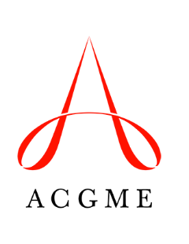
ACGME MUA/P Advisory Group
Disclosure Form

- I confirm that I am not employed by the ACGME.
- I confirm that I am not related to anyone who is employed by the ACGME.
- I have no financial or non-financial relationships with the ACGME to report.
- I have the following financial and/or non-financial relationship(s) to report:

__________________________________________________ _______________________
Name Date

